Supplementary material

Behnke 1976 age categories | Body weight | Negative (pinworms) | Positive (pinworms) | Total  (pinworms) | Prevalence per group  (pinworms) | Negative (Eimeria) | Positive (Eimeria) | Total  (Eimeria) | Prevalence per group  (Eimeria)
“Weanlings” | under 5 gms | 2 | 0 | 2 | 0% | 2 | 1 | 3 | 33%
“Young” | 6-9 gms | 22 | 14 | 36 | 39% | 28 | 5 | 33 | 15%
“Juvenile” | 10-13 gms | 57 | 49 | 106 | 46% | 68 | 22 | 90 | 24%
“Mature” | 14-17 gms | 81 | 102 | 183 | 56% | 107 | 23 | 130 | 18%
“Adult” | 18-21 gms | 62 | 82 | 144 | 57% | 87 | 13 | 100 | 13%
“Old” | over 21 gms | 54 | 60 | 114 | 53% | 22 | 6 | 28 | 21%
 | Sex | Negative (pinworms) | Positive (pinworms) | Total  (pinworms) | Prevalence per sex  (pinworms) | Negative (Eimeria) | Positive (Eimeria) | Total  (Eimeria) | Prevalence per sex  (Eimeria)
 | Female | 155 | 166 | 321 | 52% | 176 | 40 | 216 | 19%
 | Male | 123 | 141 | 264 | 53% | 138 | 30 | 168 | 18%

A. Table of prevalence of pinworms and Eimeria spp. by weight category and sex. Check at the end the exact values…

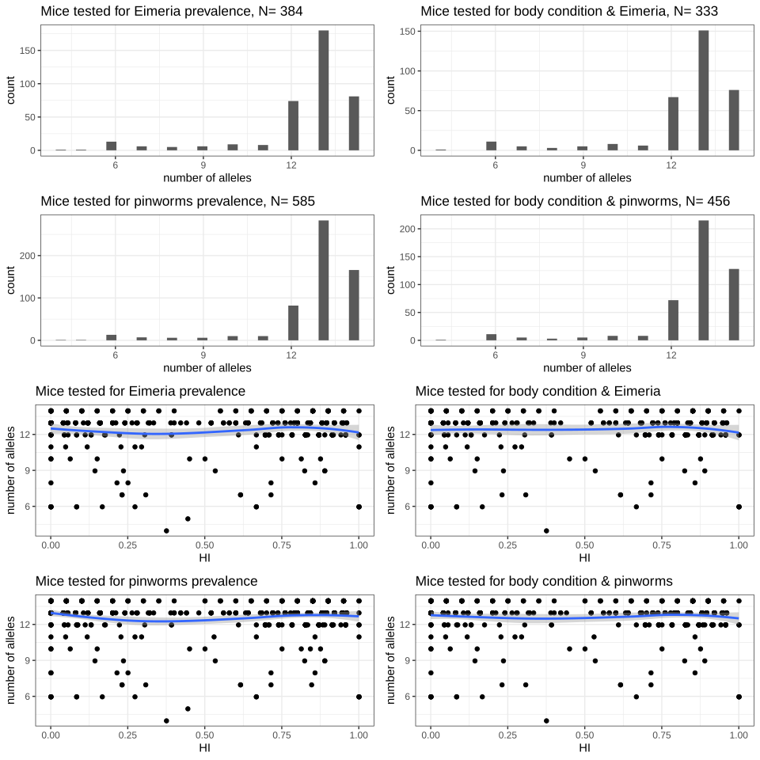

B. Number of markers used for each analysis. Histogram of distribution, and raw data with smooth along hybrid index (HI). Blue line: smooth using method “loess”.

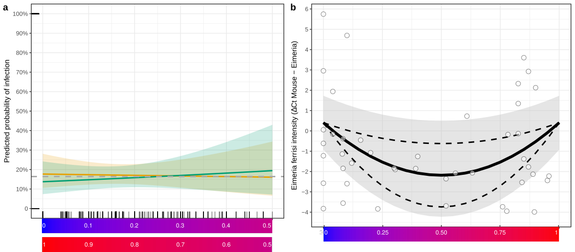
C. Probability of infection is constant and intensity of Eimeria ferrisi infection is reduced in hybrids. The predicted probability of infection does not differ in more admixed mice (a) for males (green) and females (orange)(average overall observed probability of infection (prevalence) for males and females considered together: grey dotted line). Eimeria ferrisi intensity (white dots = individual mice) is reduced at intermediate values of the hybrid index (b), represented as a gradient ranging from 0 (pure Mmd, in blue) to 1 (pure Mmm, in red). The optimized fit is represented by a solid line, the 95%CI of the fit as all parameters are allowed to vary in their 95%CI, is plotted as a grey ribbon. The 95%CI of the hybridization parameter alpha, as all parameters are fixed to their fitted value while alpha is allowed to vary in its 95%CI, is plotted as dashed lines.

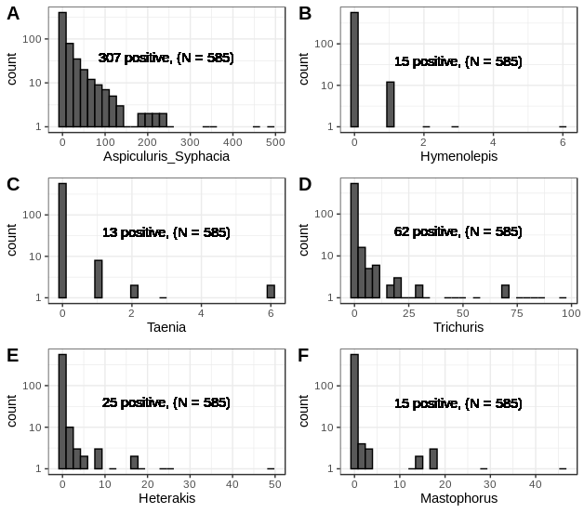
D. Distribution of helminths counts in all mice investigated for worms (N=585)

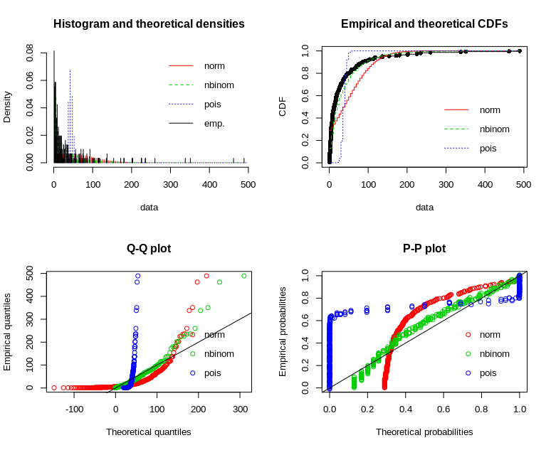
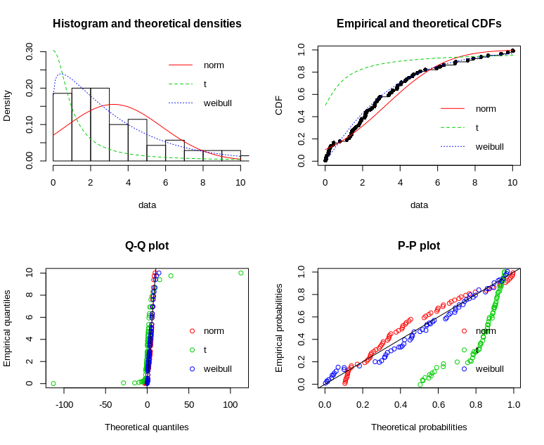

A. Pinworms B. Eimeria

E. Choice of distribution for (positive) parasite loads (intensity).
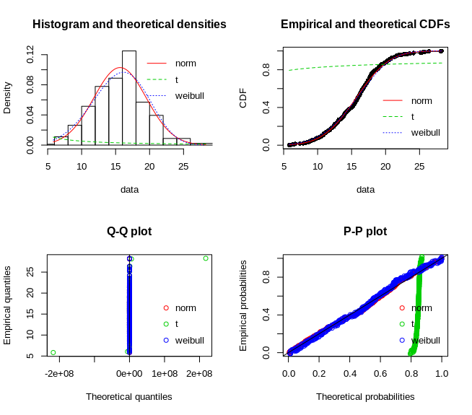
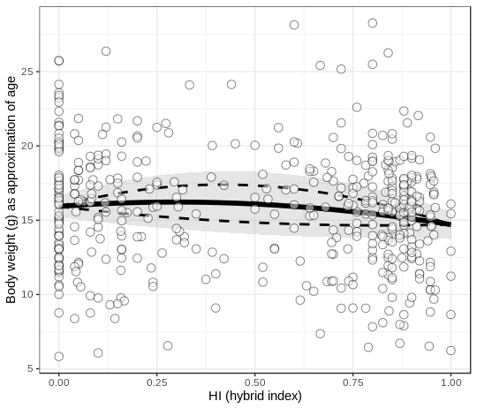

F. No decrease in mortality

